5 Things You're Doing Wrong When Programming in Python
https://www.youtube.com/watch?v=fMRzuwlqfzs

- Calling “__main__”
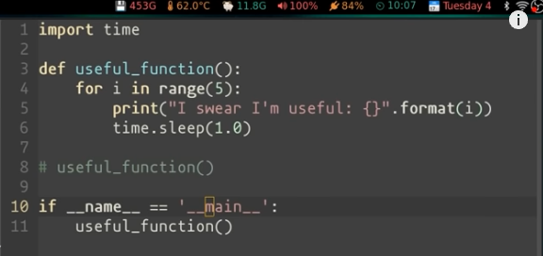

.
https://www.geeksforgeeks.org/what-does-the-if-__name__-__main__-do/#:~:text=Every%20Python%20module%20has%20it's,name%20of%20the%20script%2Fmodule.
- Every Python module has it’s __name__ defined and if this is ‘__main__’, it implies that the module is being run standalone by the user and we can do corresponding appropriate actions.
- If you import this script as a module in another script, the __name__ is set to the name of the script/module.
- Python files can act as either reusable modules, or as standalone programs.
- if __name__ == “main”: is used to execute some code only if the file was run directly, and not imported.

2. Bare “except:” instead of “except Exception:”
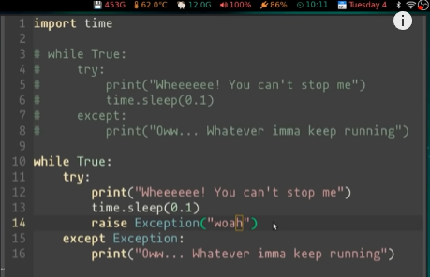
Without Exception: after exept Ctrl_C will not stop an (inadvertent) infinite loop

- Import traceback and use traceback.print_exc instead of printing the Exception error message
- 